**School of Computing and Engineering: University of Missouri – Kansas City**

**Course Name: CS5525 – Cloud Computing**

**Assignment 5 (Spark and Dataproc)**

**Name: Rakesh Rao Thakkalapelly**

**Email:** rthf8@umsystem.edu

**Student Id**: 16338585

**1. Installing Cloud SDK:**

**Google Cloud Command Line Interface(CLI):**

**2. Dataproc:**

**Enabling Dataproc API in gcloud console:**

**Creating a Cluster using command line interface & running a Spark Job for Calculating Pi Value:**

Cluster “rocky” is created successfully with 3 nodes (1 master + 2 workers).

**Pi value is** : 3.1415108714151088

**Updating a cluster by increasing or decreasing number of workers:**

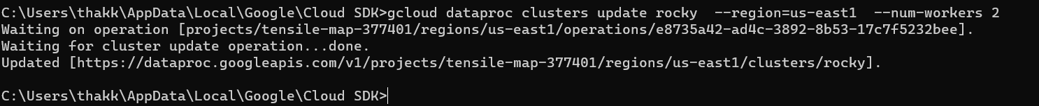

**Deleting a cluster:**

**3. BigQuery:**

**Querying a public dataset:**

**Preview the data from the public dataset:**

**Query to list 500 results:**

**Creating a dataset “babynames” in the project:**

**Creating a custom table “names_2020” and loading the data into the dataset:**

**Querying a table for a limit of 5 results:**

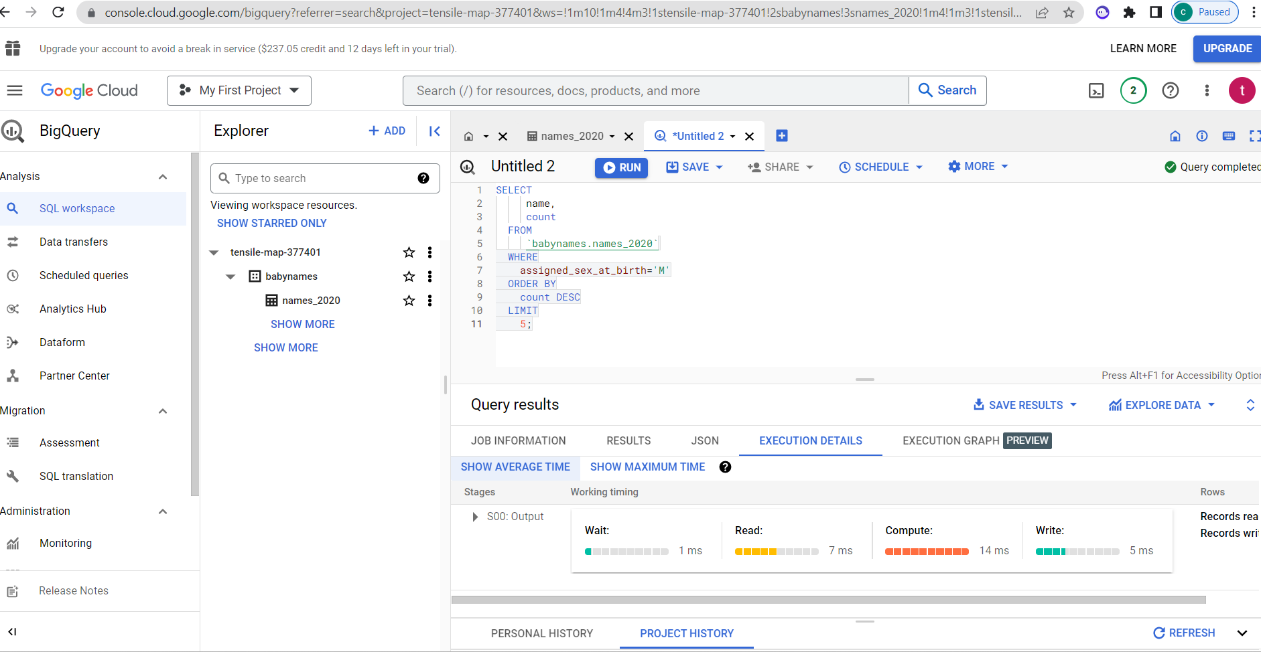

**Querying a table for a limit of 20 results:**

**4. Briefly write any challenges (or comments) while doing this assignment.**

**Ans:** Creating a cluster can be a complex and challenging task that requires expertise in multiple areas. One of the main challenges in creating a cluster is configuring the different components, including hardware, software, networking, and security, to work together seamlessly. Ensuring compatibility between these components and designing a cluster that can scale efficiently to meet changing demands are also significant challenges. Allocating resources among the different nodes of the cluster, configuring the network topology, and ensuring the security of the cluster are other key challenges.